**FAMILY RESOURCE CENTER LOCATIONS:**

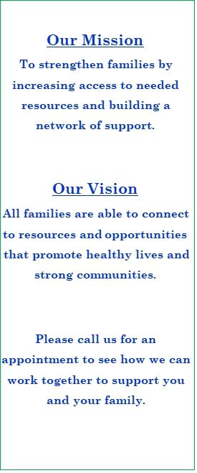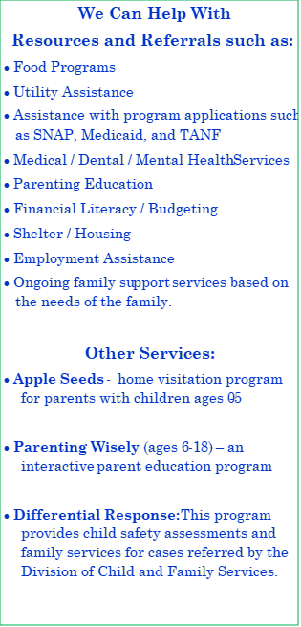

**Central Reno FRC**  
1950 Villanova Dr.  
Reno, NV 89502  
Phone: 775-321-3185

**Sparks** **FRC**  
921 12th St.  
Sparks, NV 89431  
Phone: 775-353-5733

**Desert Skies MS FRC**  
7550 Donatello Drive   
Sun Valley, NV 89433  
Phone: 775-674-4411